# Sentiment Analysis - Sentiment140 dataset with 1.6 million tweets

Deepak Sathyanarayanan

**About the Data:** This is the sentiment140 dataset. It contains 1,600,000 tweets extracted using the twitter api. The tweets have been annotated (0 = negative, 4 = positive) and they can be used to detect sentiment.

**Problem statement:** Classification of people’s opinion or expressions into different sentiments. Sentiments include Positive, Neutral, and Negative, Review Ratings and Happy, Sad. Sentiment Analysis can be done on different consumer centered industries to analyze people's opinion on a particular product or subject.

Initially we will map binary numerical classifications to labels

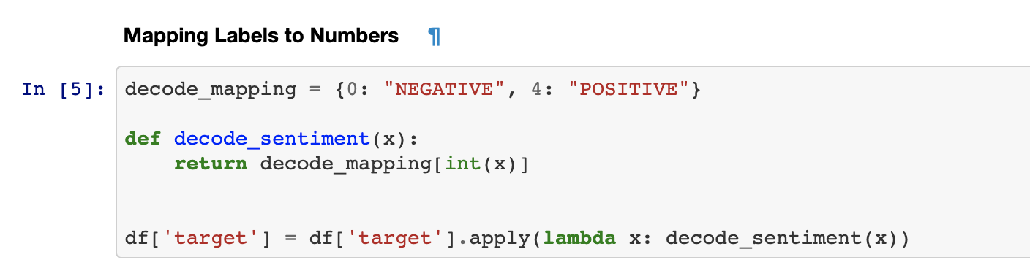

**Analyzing the dataset:**

1. **Distribution of Labels:**

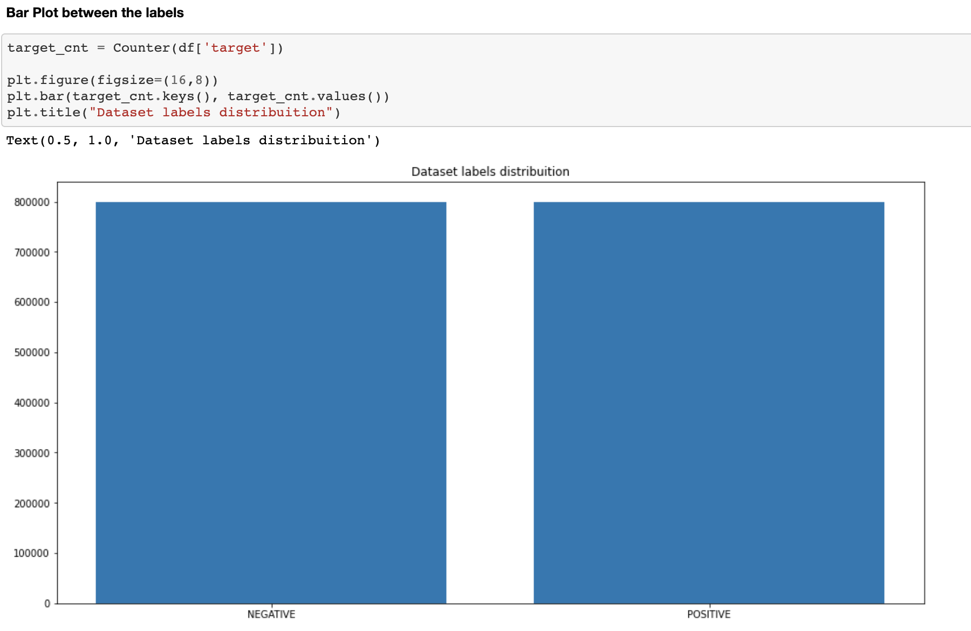

1. **Number of Words in each tweet**

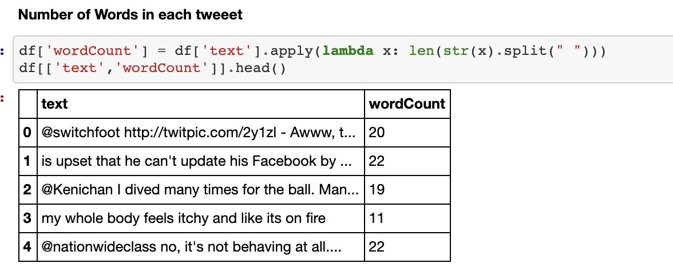

1. **Number of characters in each tweet**

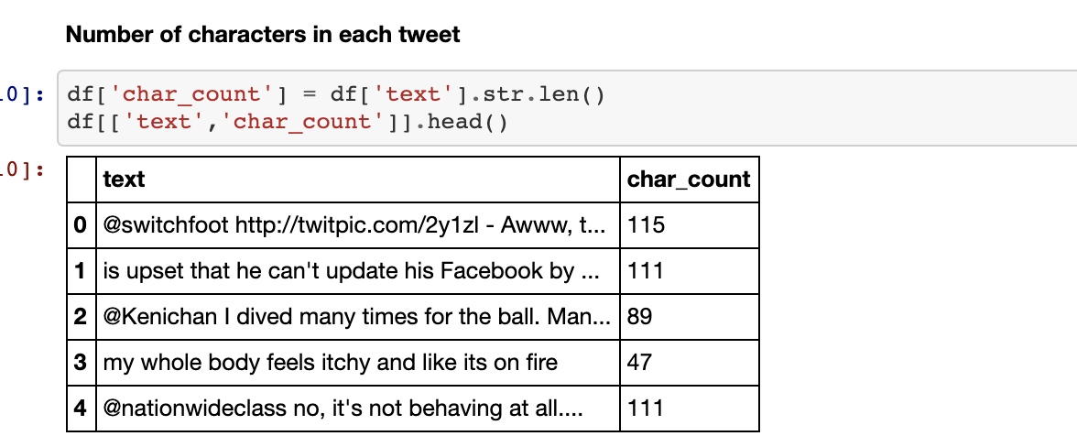

1. **Average Word Size**

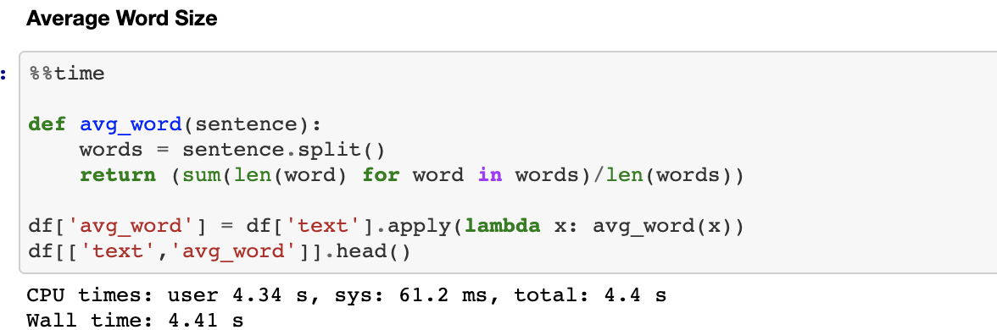

1. **Check the number of stopwords in each tweet**

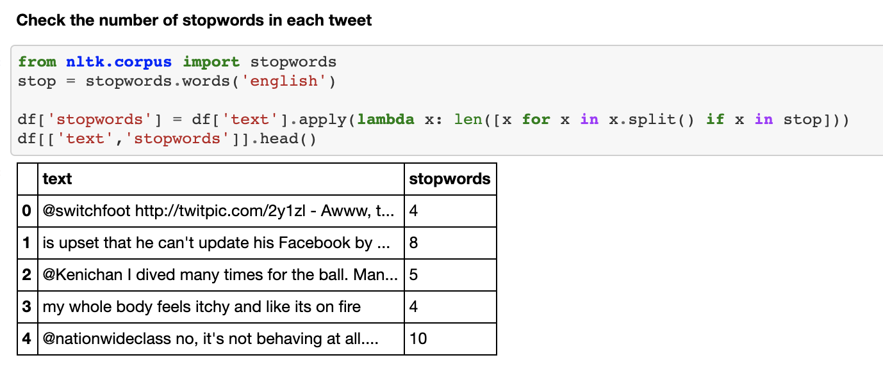

1. **Number of hashtags in a tweet**

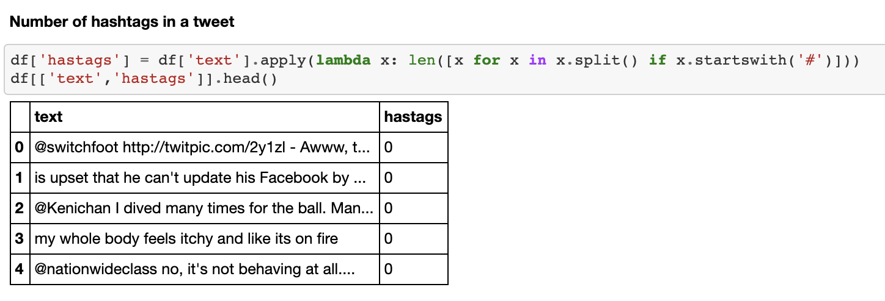

1. **Number of '@' symbols in the tweets**

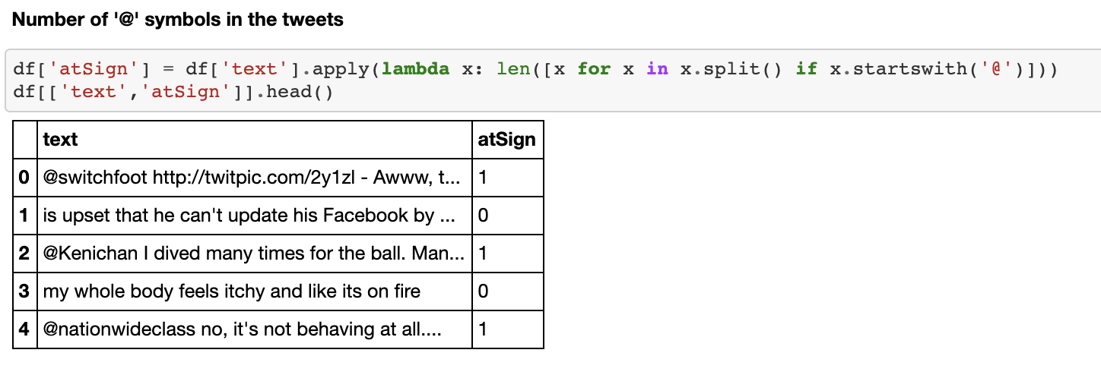

1. **Number of digits in the tweets**

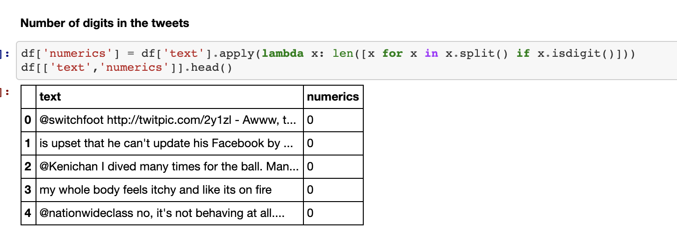

1. **Number of upper case letters in tweets**

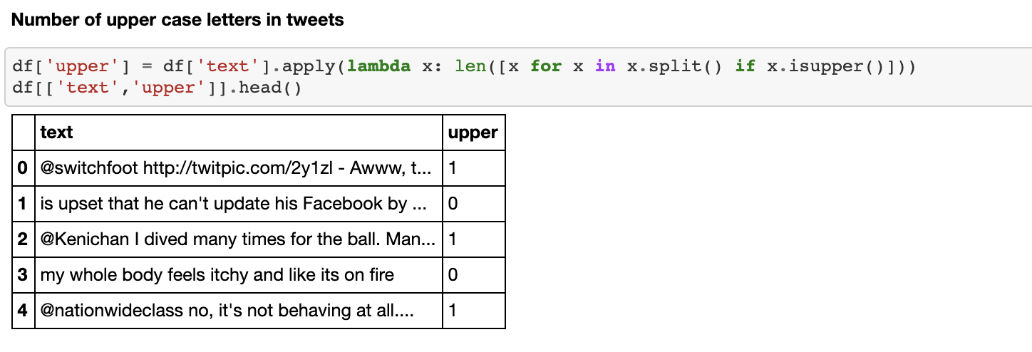

**Data Pre-Processing:**

* Stemming
* Removing unwanted characters through regex
* Stop Words removal

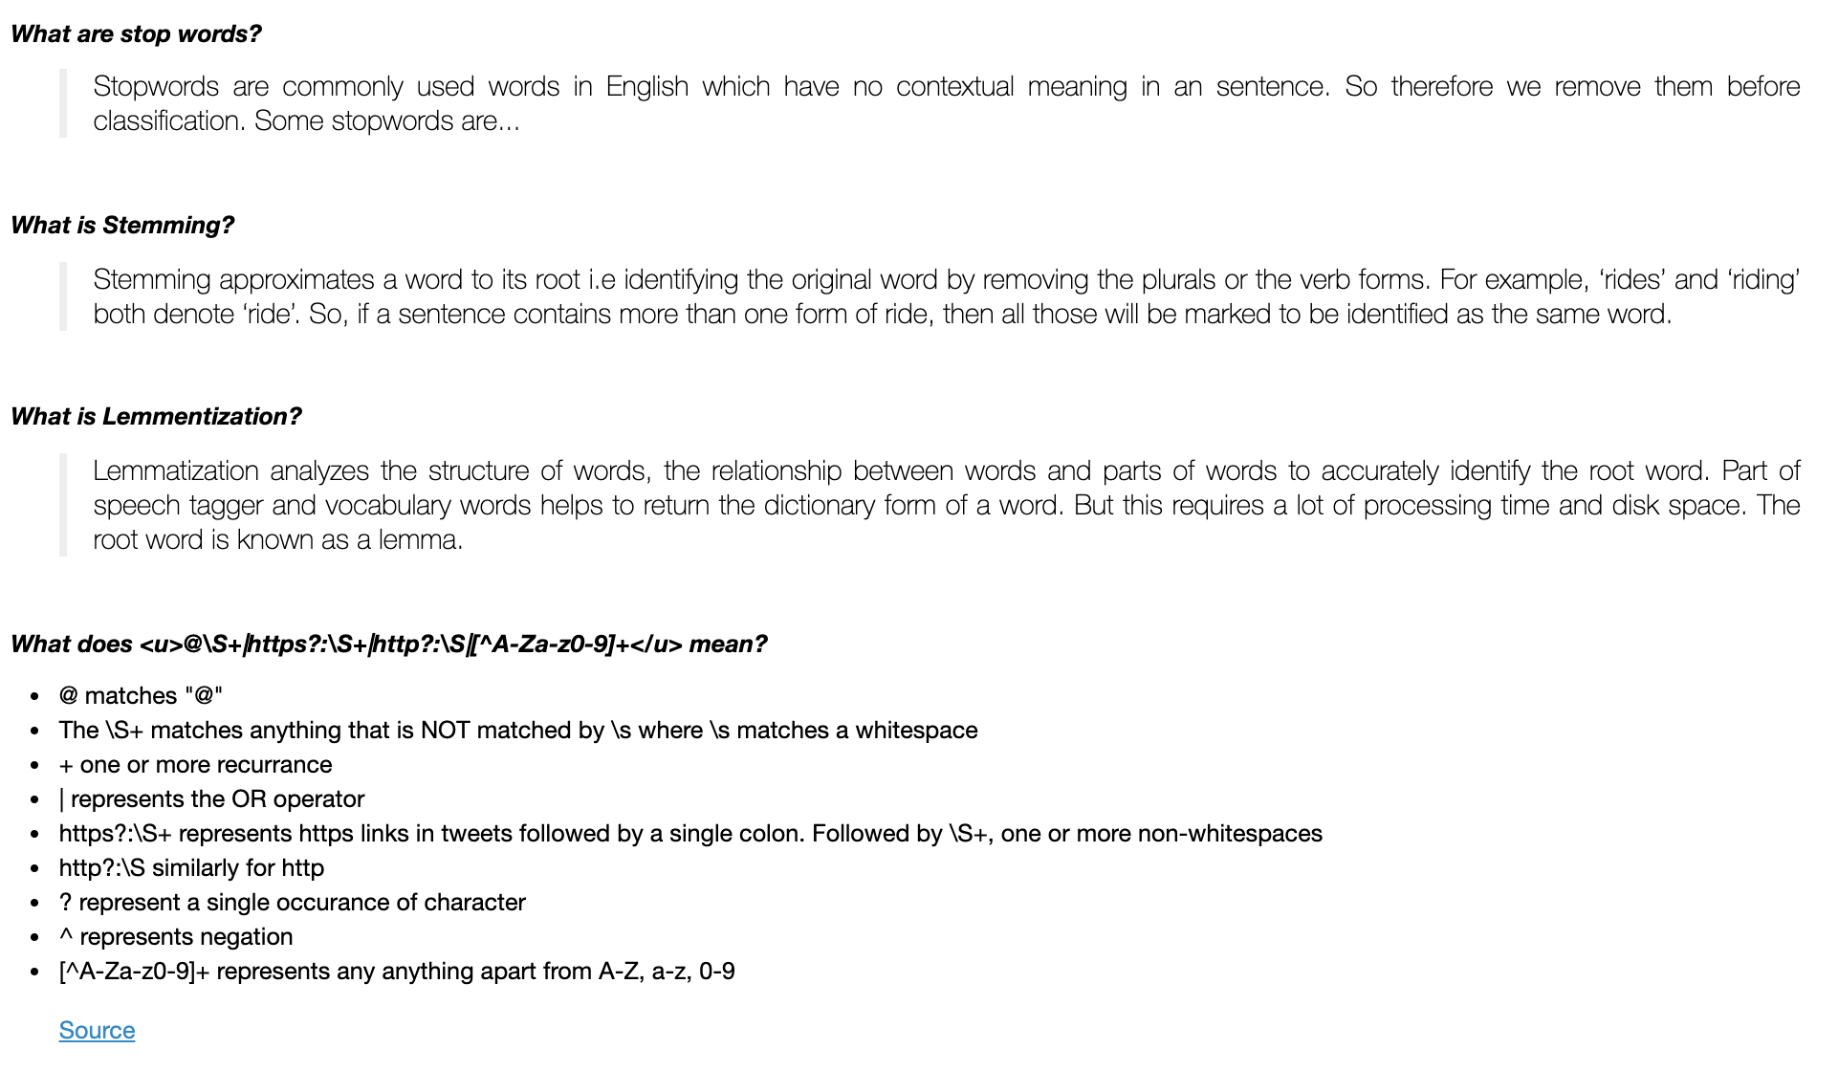

Once the above steps are completed, we can visualize the positive and negative tweets using word cloud.

Positive Word Cloud

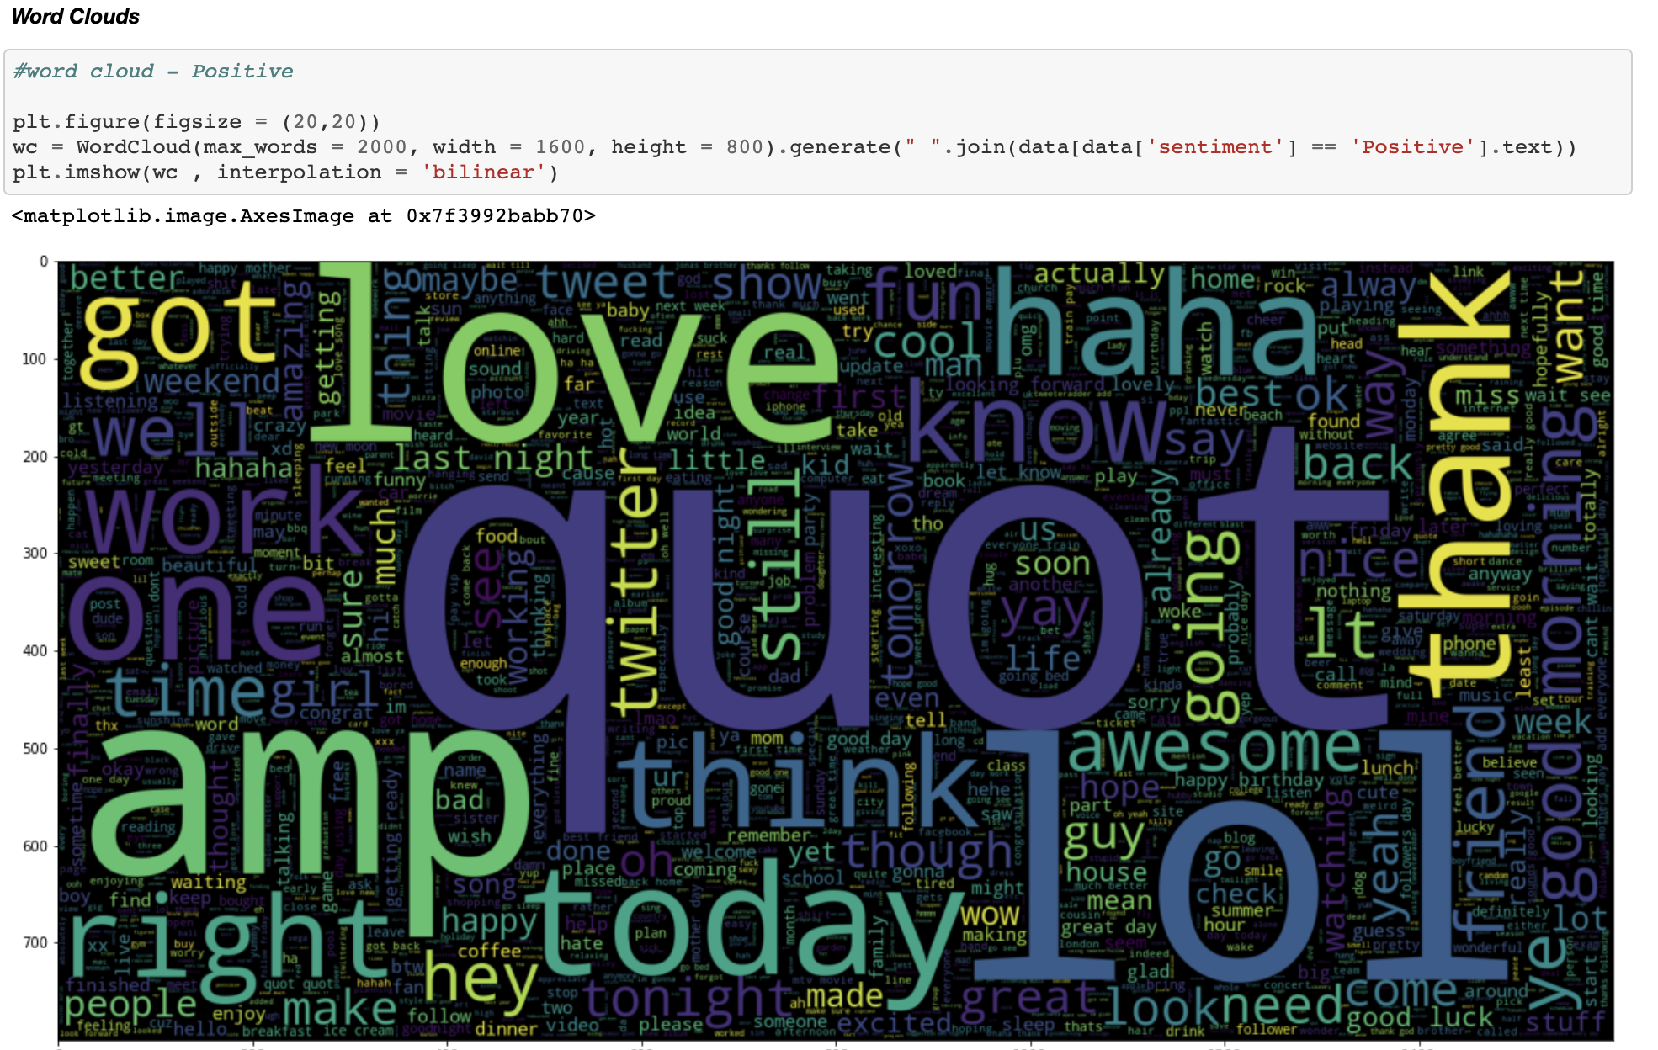

Negative Word Cloud

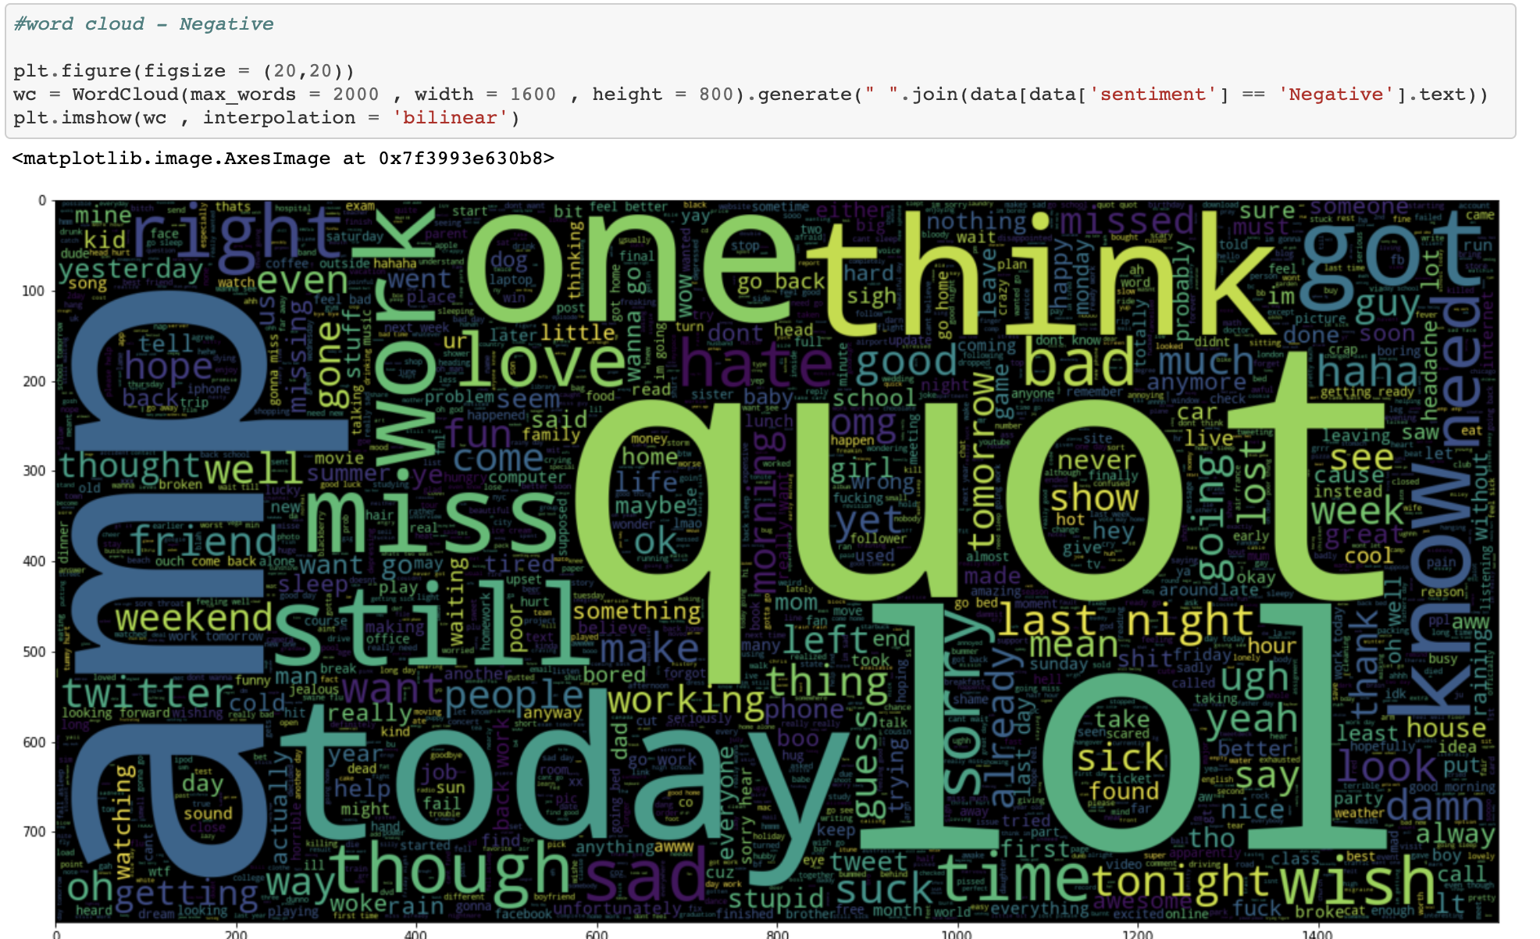

Test-Train Split:

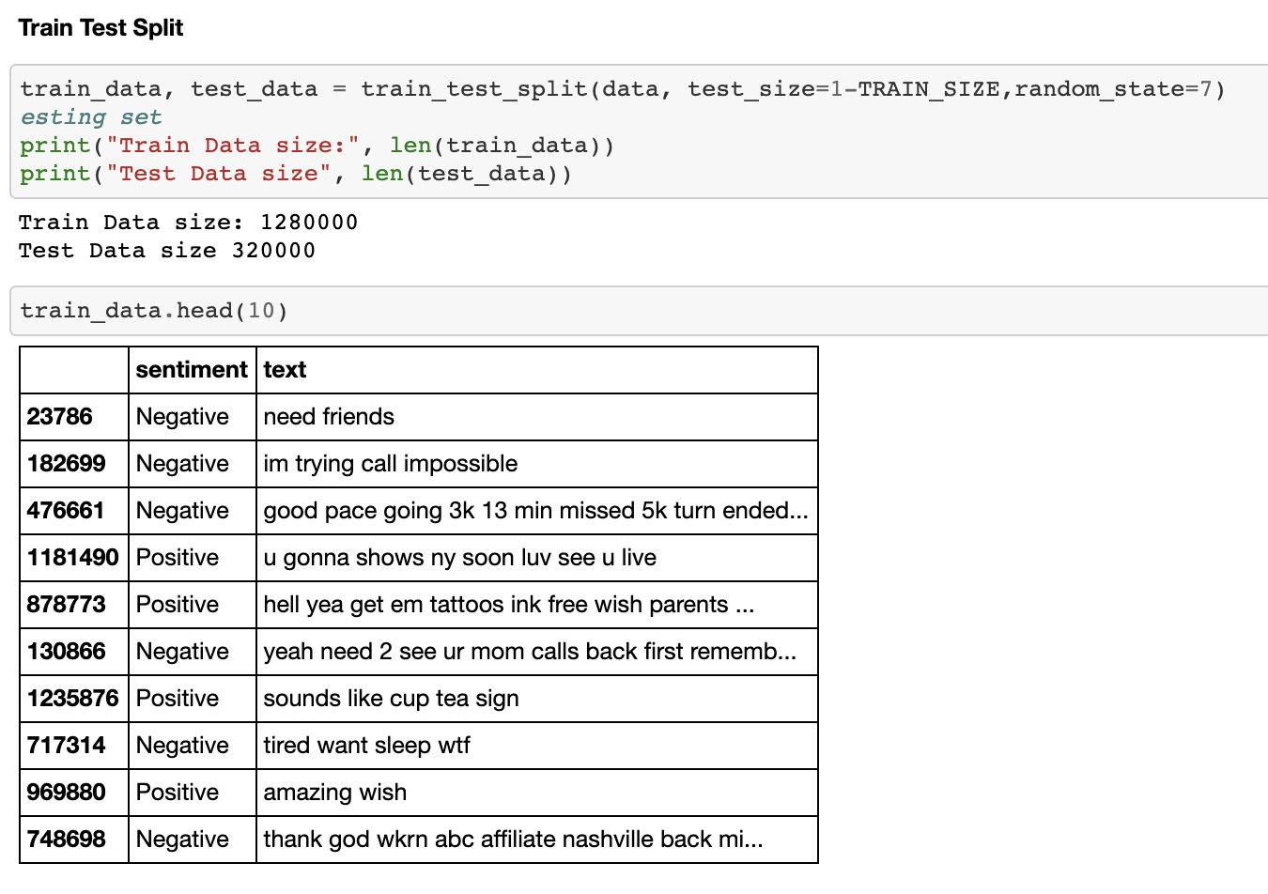

Tokenization: Over here we extract the word index for the corresponding words in the document

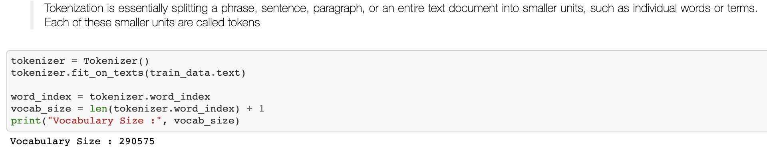

Pad Sequence: This is done in order to build a sequence model with a standard input shape

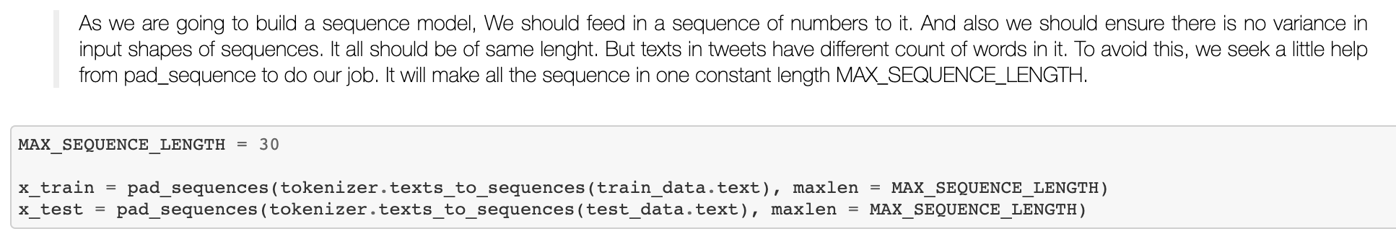

Shape before padding: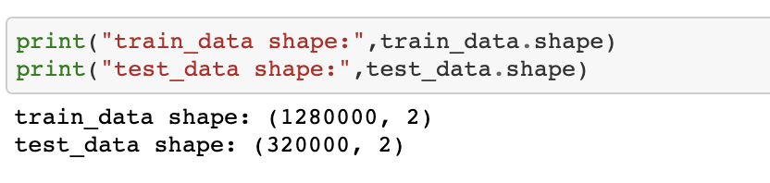

Shape after padding:

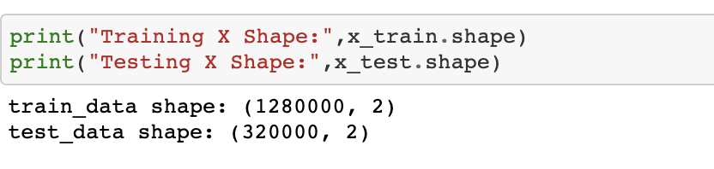

Label Encoder:

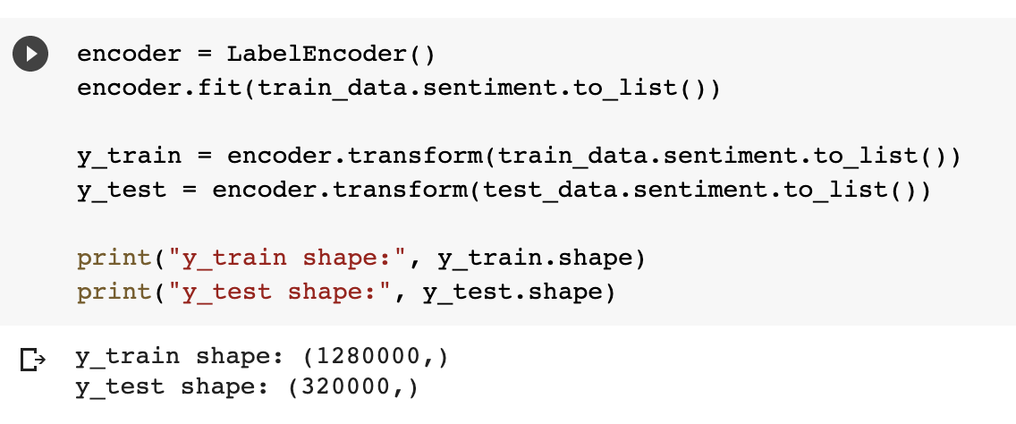

Reshaping:

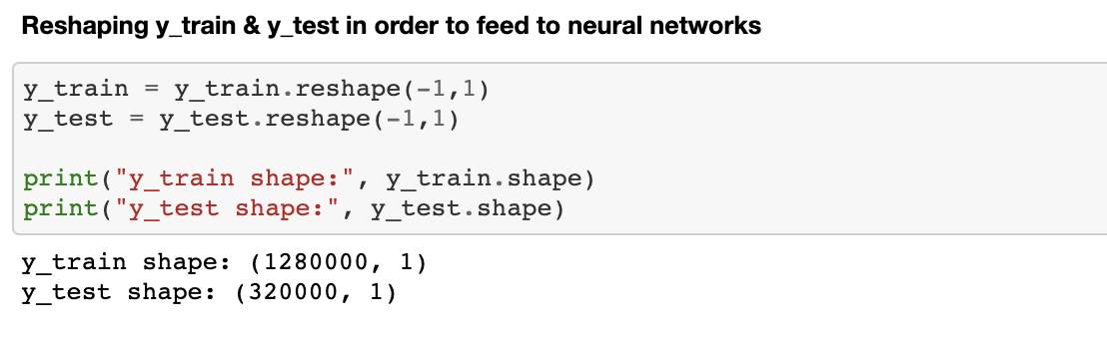

Word Embedding: There are 2 types – Glove & word2vec. We will be using Glove

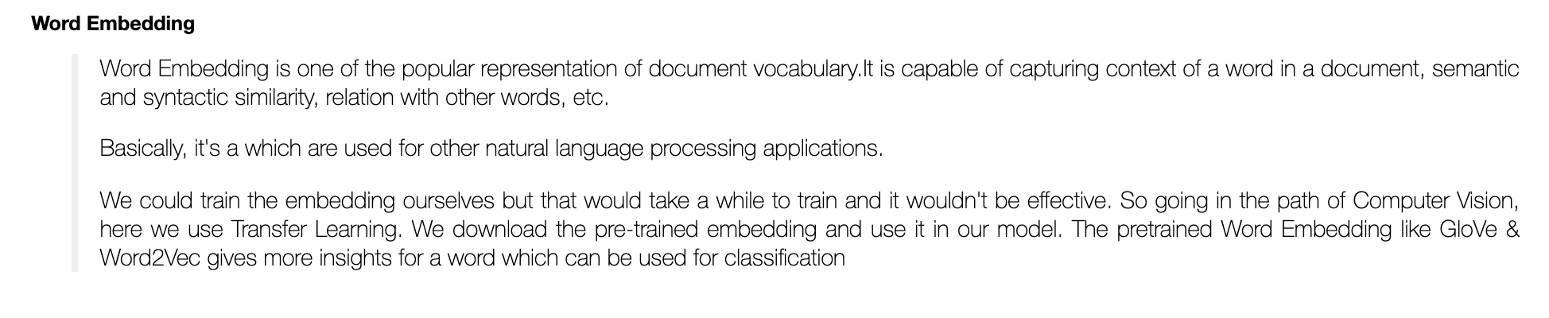

Downloading Glove Model:

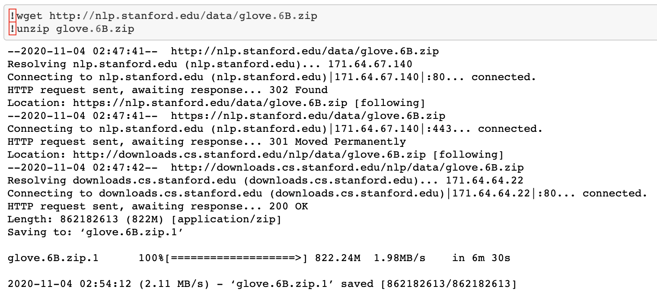

Extracting the words and their coefficients in glove model and store it to a variable called embedding_index:

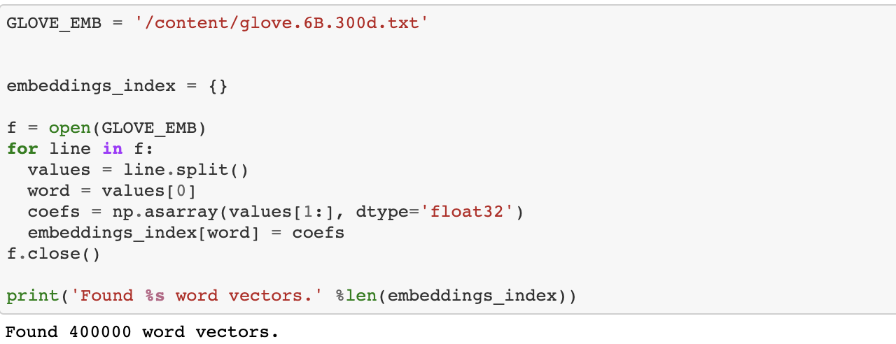

Printing the values extracted from glove:

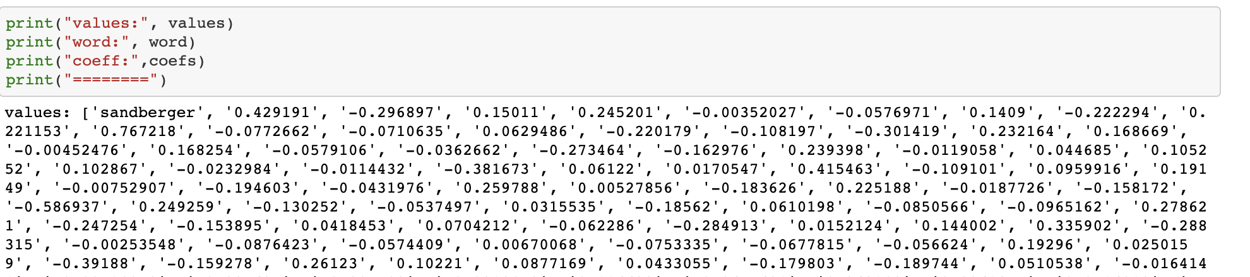

Looking at the coefficients of the word “the”:

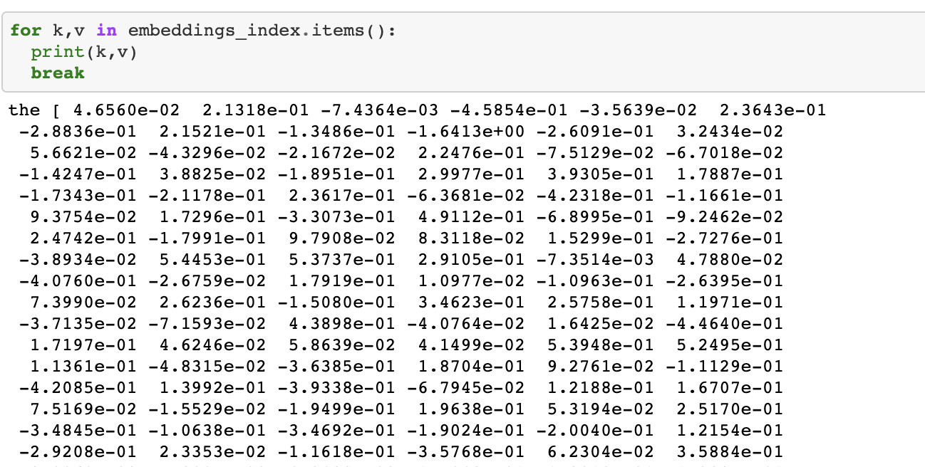

Now that we have the coefficient of words present in the glove model, we can incorporate this into the embedding layer by creating a embedding matrix

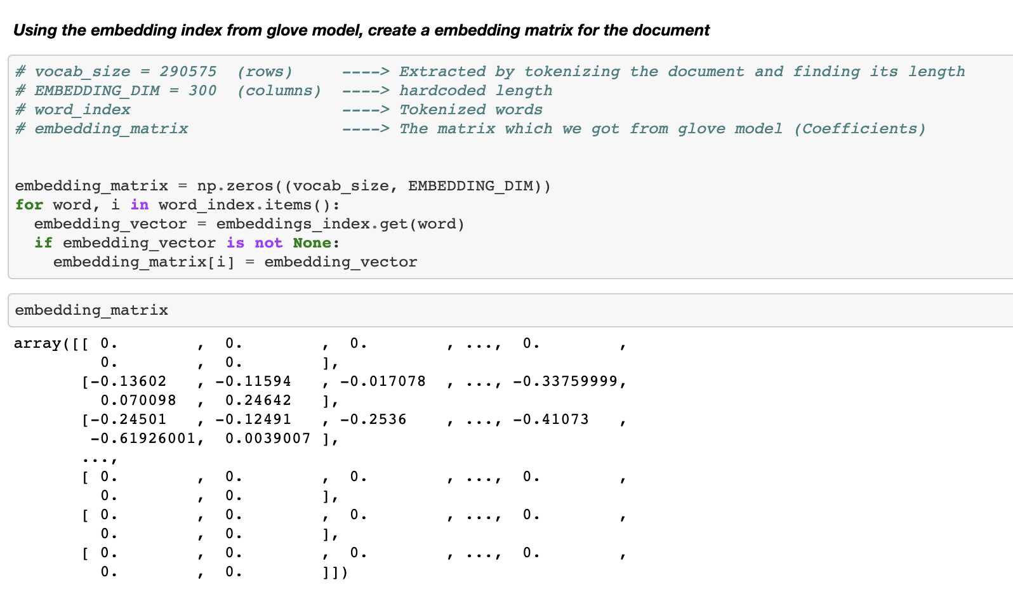

Embedding Layer:

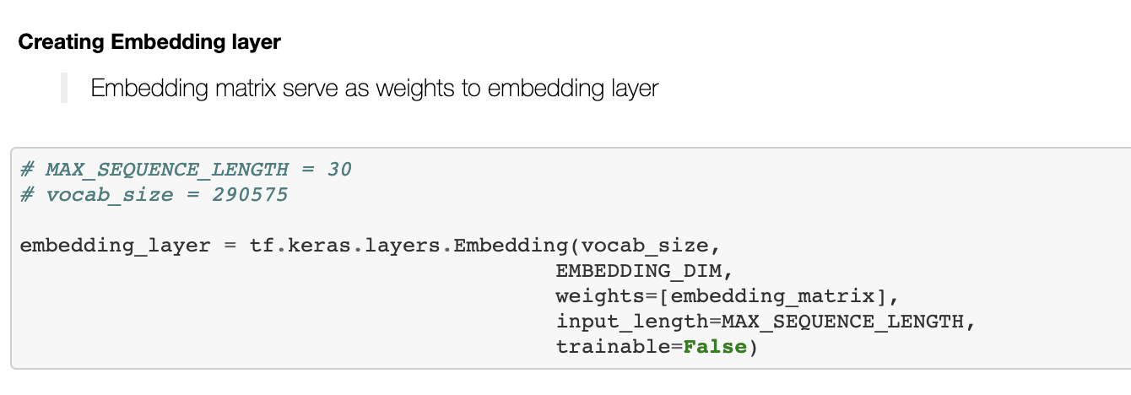

Neural Network Layer:

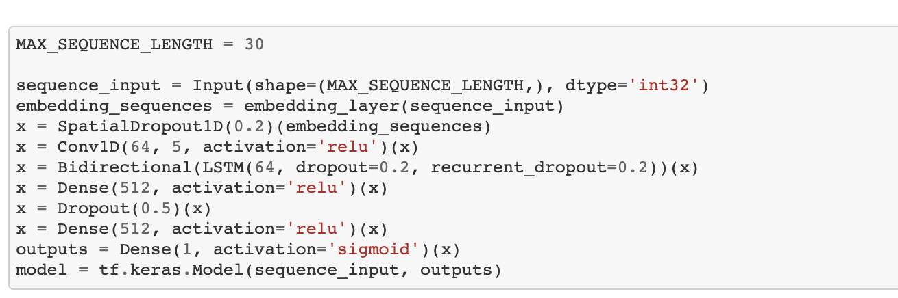

Model Summary:

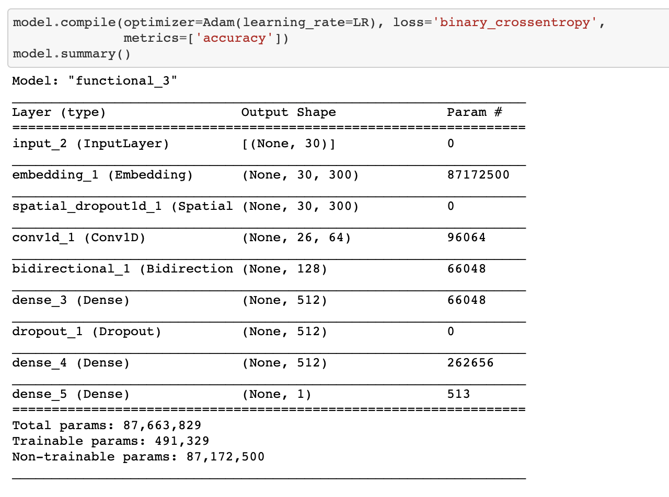

Fitting the model:

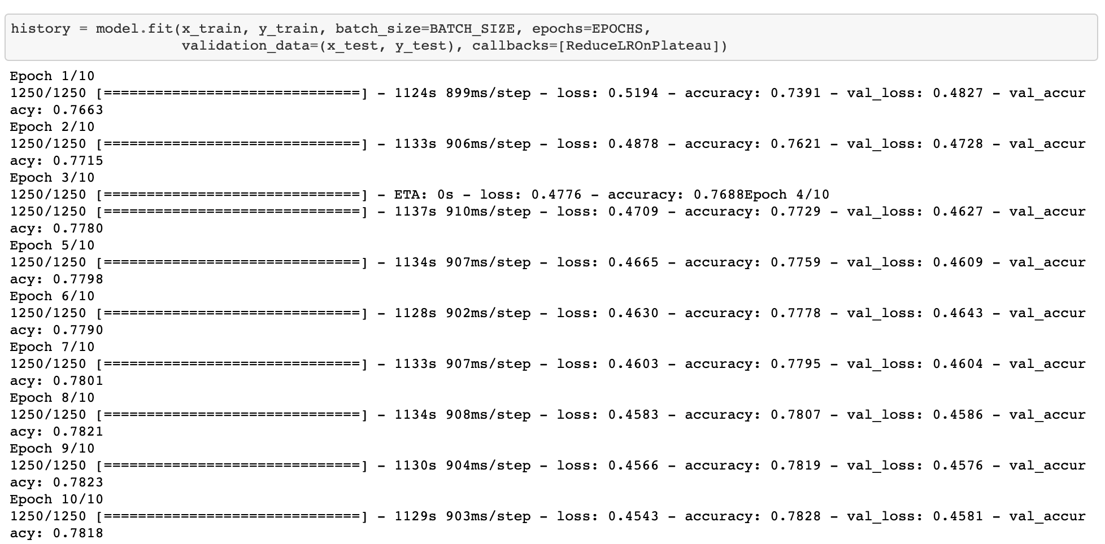

Learning Curve of loss and accuracy of the model on each epoch:

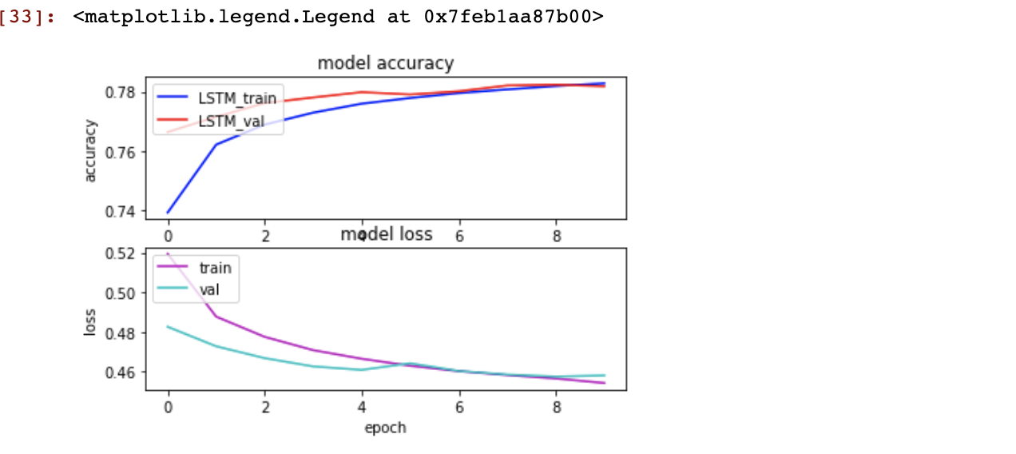

From the above plot, we can see that as epoch increases, validation accuracy is almost equal to training accuracy.

Prediction:

1. Confusion Matrix:

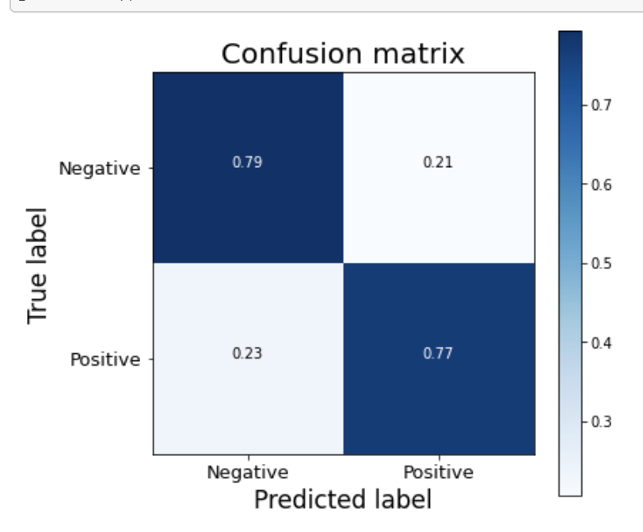

Quality**|**Actual_Values

TP – When actual value is TRUE and the predictions are correct (i.e) they are also TRUE

TN – When actual values are FALSE and the predictions are correct (i.e) they are also FALSE

FP – When acutal values is TRUE and the predictions are wrong (i.e) they are FALSE

FN – When acutal values is FALSE and the predictions are wrong (i.e) they are TRUE

1. Classification report:

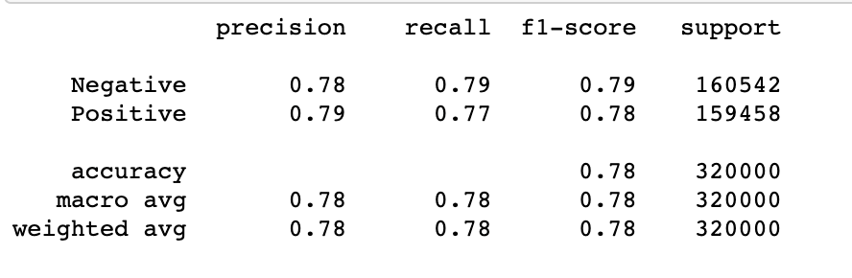

### Recollecting the concepts

#### Precision

The precision is the ratio tp / (tp + fp). The precision is intuitively the ability of the classifier not to label as positive a sample that is negative.

#### Recall

The recall is the ratio tp / (tp + fn) The recall is intuitively the ability of the classifier to find all the positive samples.

#### F1 Score

The F1 score is the harmonic mean of the precision and recall. The highest possible value of F1 is 1, indicating perfect precision and recall, The lowest possible value is 0, if either the precision or the recall is zero.

#### Support

The support is the number of occurrences of each class in y_true